TianShan Licensing Procedure
This section describe an overview of the licensing procedure
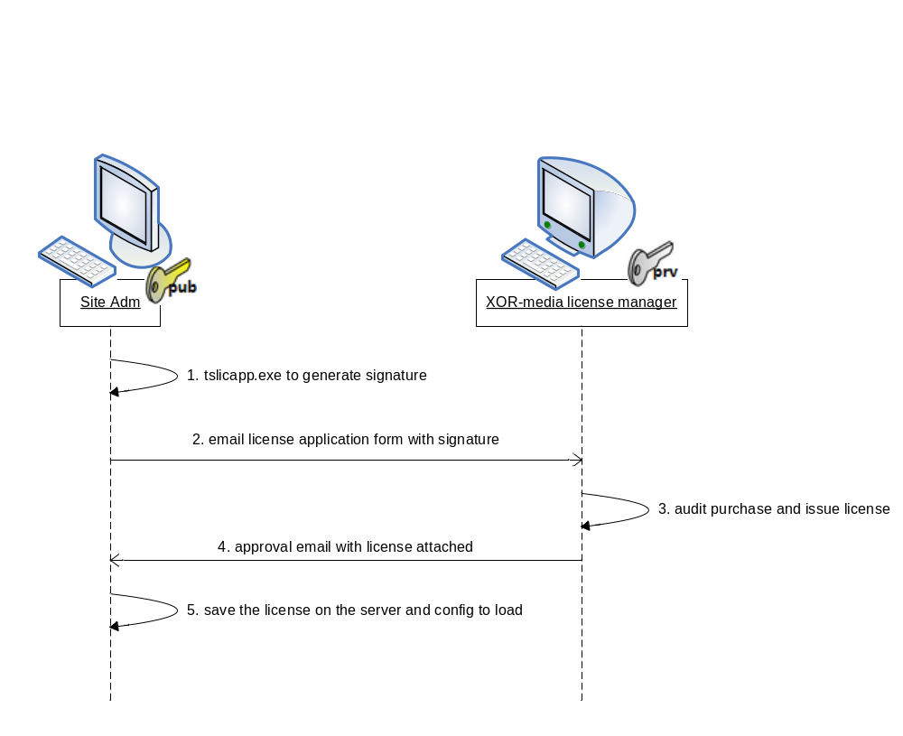

After the site administrator installed TianShan software onto the target server platform, the software by default would run for trail purpose without license, for example, the RTSPProxy service of TianShan kit would only allow up to 500 simultaneous connections and/or 500 sessions. To make the software provide more power, the customer must purchase license from XOR-media Corp. by taking the following procedure:
1) the site administrator runs the utility tslicapp.exe shipped with TianShan kit on the server where he/she want to be licensed, such as:
c:\TianShan\bin> ..\utils\tsliceapp.exe -g -o sigOfHostXXX.sig
This will collect the system information of the server, encrypted and generate a signature to identify the server platform. The signature content is a block of hex value such as:
>>>>xor-media.com SIGNATURE BEGIN>>>>
01 87 EB F8 05 A9 50 06 D5 24 51 30 52 3B 16 0D 8E B5 12 18 90 34 2E 10 2E 12 8A 66 51 90 BE 79
AB 49 D1 22 AF 55 58 35 3A 41 2B E2 31 5B 93 E2 DA 31 1D 74 BA 96 90 D8 2C 74 E0 96 9A E3 DF A6
...
FC 00 3A E2 3E 5A D0 5A 59 23 BB 64 39 7C 7E A4 78 FA 34 0D 18 9A 4F E8 C9 6C FE DA AE 65 E2 8A
>>>>xor-media.com SIGNATURE END>>>>

2) the site administrator should fill the license application form with purchase invoice code and the above signature included, then email to XOR-Media's license manager
3) XOR-Media's license manager will audit the information of the form and issue a license for that specific customer's server.
4) XORM-Media's license manager delivers the license file back to the site administrator
5) the site administrator saves the license file on the server and configures the service to load this license. For example, assuming the license file was saved as <NetId>.lic under subfolder etc of the installation, edit RTSPProxy.xml
<SocketServer license="${TianShanHomeDir}/etc/${NetId}.lic" >
Then restarts the service to take effective. If the system finger print included in the license file matches what on the server, the TianShan service will take the quota values approved, which can be confirmed in the service log file

TianShan License Issuing Procedure
This section describes the internal operations within XOR-media about the details on how to issue the license, which may not be exposed to the customer.
The data exchange of licensing is based on 1024-bit RSA PKI encryption. Every TianShan service and the utility tslicapp.exe has the public key built-in. And only the internal utility tslicsign.exe has the private key built-in. The signature collected in the step 1) of the previous section include the system information with encrypted by the public key.
1) Once XOR-media's license manager (XLM below) received such an application form from the customer, he/she must first audit the purchase records of this customer, then prepare a clear license text file in the format of JSON by naming the licensed quota values. For example, c:\Gehua_RegionA_SSS1_RTSPProxyLic.txt:
{
"RtspProxy":{
"maxConnections":10000,
"maxSessions":10000
}
}
In which, "RtspProxy" should matches the TianShan service name installed, and the quota names should match the definitions of each type of service

2) XLM decrypts the signature received by command line. For example, for signature file c:\Gehua_RegionA_SSS1.sig
tslicsign -d -s c:\Gehua_RegionA_SSS1.sig
This shows the system info collected from the customer's server, such as:
{"CPU":[{"architecture":"X86","clockMHZ":3399,"name":" vendor=GenuineIntel"},
{"architecture":"X86","clockMHZ":3399,"name":" vendor=GenuineIntel"},
{"architecture":"X86","clockMHZ":3399,"name":" vendor=GenuineIntel"},
{"architecture":"X86","clockMHZ":3399,"name":" vendor=GenuineIntel"}],
"DISK":[{"id":"W2AFX1ZB","model":"ST500DM002-1BD142"}],
"HostName":"SE1-ZhangKT",
"NIC":[{"description":"Realtek PCIe GBE Family Controller","mac":"54-04-a6-a4-9c-40","name":"{DA2C9A0F-E4D2-4B0E-A47C-3C2DE856DF20}"},
{"description":"VMware Virtual Ethernet Adapter for VMnet8","mac":"00-50-56-c0-00-08","name":"{75E1F3E6-DA88-4F5E-89BB-90435D3EC4C2}"},
{"description":"VMware Virtual Ethernet Adapter for VMnet1","mac":"00-50-56-c0-00-01","name":"{386E542F-C6C1-4713-A86E-CB6E4D46FA2D}"}],
"OS":{"type":"Windows XP","version":"Version 5.1"}}

2) If necessary, XLM adjusts the finger print schema template to take some a subset of system info appear more hardware specific, such as c:\Gehua_RegionA_FP_Schm.txt:
{
"CPU":[0,2,1],
"DISK":[3,2,4],
"NIC":[4,1,3]
}
With the releasing of future TianShan versions, the software will be able to collect more system information, this design of schema allows us to bind more potential platform specific finger prints in the future.

3) XLM then name an expiration date and issue the license file with the command line:
tslicsign -i <clear_license_file> -s <signature_file> -o
<signed_license_file> -e <expiration>
for example:
tslicsign -i c:\Gehua_RegionA_SSS1_RTSPProxyLic.txt -s c:\Gehua_RegionA_SSS1.sig -o c:\Gehua_RegionA_SSS1_RTSPProxyLic.lic
-e "2099-12-31T23:59:59+08:00"
The generated license file would be encrypted with the private key

4) XLM finally delivers the license file (c:\Gehua_RegionA_SSS1_RTSPProxyLic.lic as above sample) to the customer, meanwhile keeps a backup in the audit system

Appendix

A Licensing Transaction Samples

System information or machine finger print collected
{"CPU":[{"architecture":"X86","clockMHZ":3399,"name":" vendor=GenuineIntel"},
{"architecture":"X86","clockMHZ":3399,"name":" vendor=GenuineIntel"},
{"architecture":"X86","clockMHZ":3399,"name":" vendor=GenuineIntel"},
{"architecture":"X86","clockMHZ":3399,"name":" vendor=GenuineIntel"}],
"DISK":[{"id":"W2AFX1ZB","model":"ST500DM002-1BD142"}],
"HostName":"SE1-ZhangKT",
"NIC":[{"description":"Realtek PCIe GBE Family Controller","mac":"54-04-a6-a4-9c-40","name":"{DA2C9A0F-E4D2-4B0E-A47C-3C2DE856DF20}"},
{"description":"VMware Virtual Ethernet Adapter for VMnet8","mac":"00-50-56-c0-00-08","name":"{75E1F3E6-DA88-4F5E-89BB-90435D3EC4C2}"},
{"description":"VMware Virtual Ethernet Adapter for VMnet1","mac":"00-50-56-c0-00-01","name":"{386E542F-C6C1-4713-A86E-CB6E4D46FA2D}"}],
"OS":{"type":"Windows XP","version":"Version 5.1"}}

Signature Generated
>>>>xor-media.com SIGNATURE BEGIN>>>>
01 87 EB F8 05 A9 50 06 D5 24 51 30 52 3B 16 0D 8E B5 12 18 90 34 2E 10 2E 12 8A 66 51 90 BE 79
AB 49 D1 22 AF 55 58 35 3A 41 2B E2 31 5B 93 E2 DA 31 1D 74 BA 96 90 D8 2C 74 E0 96 9A E3 DF A6
2C 18 04 B0 05 C8 B4 E4 0B 44 70 82 8A 9D 59 58 FD 53 8F B5 B0 63 1C 0A BB B1 F7 D5 2E C1 B1 FE
C5 9F C9 33 BF B7 EF 78 F5 4E 0A 5F B4 D7 B1 52 98 12 5E 7D C7 88 F3 CD 59 56 E4 37 69 82 13 A0
3E F0 D6 0B 22 6C 20 43 C1 BC EF 3A DC B9 64 B0 D5 7A 2B DA 82 21 B7 79 25 36 CC E2 71 F6 E8 99
7F D9 A7 2B 96 73 89 12 79 16 FE 54 9D 3F D3 B2 17 88 38 24 85 6B 86 29 DB D6 03 D8 32 6B 47 47
34 27 8F 63 33 60 6F 67 A5 FE 87 D6 8A 0E 28 1D 73 CF 3B 57 0B B0 91 68 8B 82 E5 98 1F 8F 34 06
F3 2F 46 84 EB 46 78 65 45 72 2C 1D 92 CA A1 79 CE 28 D5 3B 47 BD 48 1F 6F 97 14 6B B2 FF 4A 70
E4 28 40 29 46 6C 07 2D D8 AD 53 7A 94 6E 92 3F 11 63 16 2C 35 35 07 32 A7 90 9B 70 D4 5E 8C 03
26 B4 4E AF A5 E4 43 3D 61 FB C7 10 37 33 E5 56 57 00 FB 57 6D 40 A3 F6 9E 6A 09 8F DC 0D 0A 25
E7 C1 75 E4 6B 98 D0 9A D5 51 85 38 37 BB 6F F3 E0 6C C5 D0 13 A4 86 BD 07 AD 10 F9 A5 E3 69 78
40 3A 0F 41 2E C4 AD CB 04 63 B9 74 B1 78 21 94 81 4B CB 4F 52 4F C5 4B 54 F9 A7 53 24 2B 3A EA
81 7B 4E 1C C5 75 B9 E0 CB 28 DB 4A 04 E1 9E 44 12 C0 7C E3 98 09 B4 15 1F D8 9E F7 D4 A4 D3 0F
03 A8 0B 96 71 13 B7 83 D7 FB D5 D5 AF 13 CE 0F 1E 30 1E 7F A4 7F DD E6 6F 14 A6 57 B7 EF 67 37
CA 45 A8 0C 30 16 7D 29 53 F6 2F 20 D4 F7 B2 77 03 93 C5 02 39 2F 65 89 73 88 54 16 09 42 A8 12
6A 68 69 6E FF 70 8E 97 E6 84 8F 13 50 26 7E 39 C8 B2 B6 86 85 AC ED 59 FE 9F 21 4D 06 D7 47 A1
6C 81 1D E8 4D 51 54 5E F4 5D 2C 67 E8 32 C5 CC 29 98 A6 89 E3 95 2B 50 04 61 8E B1 0A 33 7D CC
F9 23 D6 54 C9 A9 F5 13 9E 49 07 A7 81 A3 A2 C2 F6 EF 1B B0 6A E1 9F 57 33 BE 10 E3 76 F8 14 E1
E4 C9 29 22 B8 FB 43 3A 44 65 AC 2A D2 41 CF 30 6C 1A F9 65 1B 4E 5F F8 ED 67 F4 74 FF C8 C1 B4
36 94 24 31 CB A2 44 98 16 7C 22 90 FA 7A 26 14 84 D1 55 44 7E EC 4D 2A 63 22 54 39 50 F3 41 B2
15 FF 7F 04 26 FC 3F 5F 48 FE 49 99 C0 E0 73 79 68 5E D9 2A 16 72 B8 BE 5B B4 DB 99 DF EE B1 30
9F 6A FD D3 8B A9 E5 01 40 09 16 A0 34 46 A4 2B 49 49 0D 10 2D 48 C4 36 5B 0A 02 83 30 B1 41 3B
22 00 18 5B A7 54 08 B8 DF 93 1A 7E 9C 8F A1 A1 A3 F4 3D 45 01 49 D2 0F C8 D1 0B DB 45 82 E6 3E
81 09 12 4C 64 FD 3D 42 11 B4 5A FA 5C 74 CE F0 07 6D 73 21 1F B5 5A 68 8D A4 D8 34 56 83 70 77
7E 9E FD 99 B3 93 D8 BE 74 AF A7 8C 37 1F 08 C4 F1 69 7E CF 47 B4 1A 59 AA 4B B9 A7 A1 19 C0 73
61 18 F7 28 22 E1 AB AB 5B 2B 91 2C 5D 01 34 F5 8F 95 04 77 1F 93 A6 B9 AC 73 5B E0 55 58 36 00
C2 14 82 7D 61 15 44 7B 2C 82 FC E2 6A 6C 9A C9 37 92 54 2B 53 6B F5 71 73 41 C2 60 A2 F1 46 34
3E 62 AB C7 B3 3F 14 7A AC 7A 99 B6 85 91 FF 14 C6 4F F1 C8 90 55 CD 34 0C F4 EB FF CF B6 45 94
CA ED 72 DF 2D E9 8A 8B 87 D6 AD 1F D8 B4 22 80 A2 1E 6F 0C 31 02 9F 28 95 03 6D DD C5 0F C4 6E
50 8F CA AB 54 8B D3 99 1F A5 2E 78 88 85 D7 89 C5 D1 E1 7E DD 86 72 CE EE E8 89 92 A0 BC A8 31
42 17 F2 5C 80 2E 0B F3 66 AE 0D C4 62 2A 57 01 B8 DE D9 C7 87 EB 78 86 D8 47 2F A5 79 2F 7E D1
FC 00 3A E2 3E 5A D0 5A 59 23 BB 64 39 7C 7E A4 78 FA 34 0D 18 9A 4F E8 C9 6C FE DA AE 65 E2 8A
>>>>xor-media.com SIGNATURE END>>>>

Clear RTSPProxy license content prepared
{
"expiration":"2014-06-25T02:52:05.781Z",
"rtstProxy":{
"maxConnections":1234,
"maxSessions":10000
}
}

System Info Filter Schema
{
"CPU":[0,2,1],
"DISK":[3,2,4],
"NIC":[4,1,3]
}

Sample License File Issued
>>>>xor-media.com LICENSE BEGIN>>>>
29 E3 2A 09 7F 40 A8 18 89 A4 36 DB 6F 86 7C 93 BA 01 24 4C 7E 5F A0 39 1A 6D A7 75 4F DC 7C 90
D5 4F F9 FC 9C F4 BD 57 D2 1B 14 B5 CE 3F B6 8E 77 59 C4 99 84 E7 2A 6F 77 3C AF 38 8E F4 D0 49
FF 44 5A 0E AA 94 16 EF E3 F8 D3 D8 87 64 C3 63 EA 3D 75 89 C6 34 83 4D A3 91 57 1F DE D8 19 4D
1B 70 B7 31 0E 85 4D FC 3C 02 03 EA 19 03 A1 C3 2E 7C E6 CB 8B A8 EF E5 AD 50 FF B3 E7 1F 79 C3
56 A5 C5 1B 0B BF CB 7B EF 9B FB 9B EE 52 79 71 1E 59 26 5B F6 B5 ED 13 3F A8 F3 D3 1C 11 F1 5A
B2 CA 54 60 BC 09 61 F1 6A 75 71 F9 0A C5 5A F4 5A 24 75 7F E5 54 F9 1D 9B 64 C7 E5 0D B3 8C 58
74 B7 74 64 1E F7 98 66 95 37 5D C6 61 7A 90 C5 7E 24 8A E4 D0 CD 3C 1E 26 07 01 FC 10 D6 67 33
84 B7 E4 A7 91 D3 DB 5D 25 BC 3A E9 78 34 B1 4F 72 8D 91 A4 EA F3 6D 59 76 B2 E6 28 F5 92 F2 03
71 9D A2 BC 35 16 4C 06 2A 37 6F F2 7A 20 DF 56 72 40 91 36 F3 96 7B B0 9B 03 46 2D 7A 5E 5B EC
08 7A 9C 87 92 D7 25 4B EF F9 80 00 C7 5E 66 66 BA 98 C1 91 CC C4 95 FD 34 5F 8D 8F FE 5A C3 6A
09 B2 ED 44 6E 5B 46 C0 90 0A 48 95 8A DD 96 7E CD E9 12 94 C2 B7 7E E4 1C 36 1A 51 16 63 A5 EE
9D 45 14 0F 55 6C F3 7B AA DA 39 55 50 3A 05 3C BF 25 A8 4D F3 82 F8 6C 6A 2D D1 34 00 BD AE C3
80 D6 66 FC 0D 60 4E 8A C5 3D 5B 3E 6D A6 B3 8C 15 55 BA 3A A0 70 76 C1 F8 A3 B3 EA BE A0 BB 28
F9 98 6C 3B 3A 93 52 08 A8 DD 98 3F 3E 09 F9 17 52 4C A3 72 D2 AA 33 D9 C5 3B 1F 42 4D 84 1F C9
43 5E F5 85 91 A8 53 8B 17 B7 47 D2 84 47 62 80 2B 84 BF 76 29 12 FF 43 68 FA CE 40 7C FD 18 1C
C5 47 15 D7 61 9F 4B 63 6D E4 2C 4A 50 AD 5D FC AA 81 59 6D FB 62 52 36 28 B7 19 69 10 B5 22 BF
C5 5D 64 50 CB 49 D3 F2 DB BF 02 0D E8 EA 91 40 C2 97 9C 9D 41 78 B8 98 3C 3F BB 78 53 2D 0B C8
6E FD 7B 11 BE F3 06 93 FC 46 4E 06 CF 16 AD 0B 41 7F C4 14 E1 6A 96 79 1E 0E 72 C1 D6 84 4E 8A
14 41 55 1D E1 8F A6 4E 9F AF B0 50 D4 64 43 50 B1 E8 28 31 A7 F7 9A 5C F4 37 34 3D CA E1 FD 91
FC EF FB 86 AF 71 A0 2D 84 97 9E 25 70 AC AD 06 45 D7 7C 90 92 03 54 6C 8A 73 C1 7F 29 E6 2E CB
CC F3 87 F2 5F 89 05 80 64 C4 01 A4 22 B3 04 E6 A4 36 DD A4 FB 6B 4B 9C 46 51 B6 0C DC 7F 74 F3
FB 88 56 94 04 06 63 3B FF C4 6D AC 70 68 25 22 DB A6 71 56 AD 2F 2A CD E1 1F E4 AD 79 88 E6 E9
D9 E9 60 37 EB 53 90 DA 5C D0 20 75 4A 0D 70 FF 30 91 4A 94 15 DF BF 97 7C 33 F7 C3 5E 84 C1 A0
3D 8A 29 A7 28 F3 93 19 F3 DD 70 72 50 A0 56 2F 3A E5 AC F0 16 5D 0B F3 5A 59 A8 96 66 B3 DF AE
>>>>xor-media.com LICENSE END>>>>

see Appendix System information or machine finger print collected

